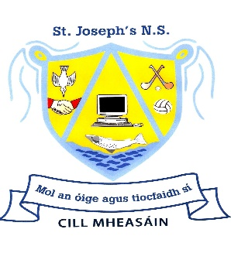
Handwriting Policy for Kilmessan Mixed National School

Aims
- To ensure good letter formation from Junior Infants to Sixth Class.
- To ensure that all children are using the correct pencil grip.
- To ensure legibility of all writing.
- To help develop speed, accuracy and writing fluency.
- To ensure uniformity and consistency in letter formation from class to class.
- To provide children with a relevant life skill.
- To develop and improve fine motor skills in the early years.
- To facilitate the neat presentation of all written work.
- To help in the improvement of spelling.

General Writing Guidelines
Before any writing begins make sure children are sitting comfortably, they are holding their pencil lightly and that they have most of the forearm of their writing hand resting on the table.
For left handers, writing from left to right can be difficult. If the child is left-handed they should hold the pen or pencil at least 2 cm away from the tip so that they can see what they are writing.

Handwriting programme
Junior Infants
- Children in Junior Infants are encouraged to scribble and draw.
- They complete various prewriting patterns to strengthen fingers and hands.
- These patterns will also create awareness of left-right, top bottom orientation.
- Cursive writing is introduced from the start in Junior Infants & is maintained throughout the school. The Just Cursive Programme is used to introduce children to letters in Junior Infants. With the introduction of each letter the children are taught how to form the letters correctly. Relevant rhymes for letter formation are used (see below). A number of other techniques are used, such as finger tracing on the table, in the air or in sand.
- Children are encouraged to find a hand dominance and pencil grip that is comfortable and allows good writing. They are taught and encouraged to have good posture for writing.
- The children in Junior Infants also use Just Cursive workbooks to develop their fine motor skills in pre- writing activities and to practise letter formation. Later in the year, the Just Cursive Junior Infants Practice Copy is used to re-inforce the skills acquired.
- The following order is used when introducing letter formation in Junior Infants.
1. c, a, d, g, o, s, qu
2. i, j, t, p, n, m, r
3. e, l, b, f, h, k
4. u, v, w, x, y, z
- Children are expected to be able to write their first name.
- Pupils see teacher model good hand writing.
- Practise, practise, practise.

Senior Infants
Pupils use the hand writing copies (B2) from Senior Infants where proper letter formation of lower and upper case letters is taught to the children. Capital Letters are taught in alphabetical order (see below).
Senior Infants also use Just Cursive workbooks to practise letter formation and to reinforce learning.
- Children are encouraged to write and draw frequently throughout the year.
- Emphasis on proper pencil grip and good posture is encouraged.
- Children are made aware of the importance of putting a finger space between all words and are expected to keep all writing on the line.
- Children are expected to be able to write their first and surname using capital letters when appropriate
- Teachers model good handwriting.
- Practise, practise, practise.

First Class
- Consolidation and reinforcement of Senior Infant work.
- There is a greater emphasis on proper letter formation, pencil grip, writing posture and on the quality of presentation.
- Children are expected to be able to use capital letters and full stops when writing.
- First Class follow the Just Cursive programme
- Children use their handwriting copies for practice of their letter formation.
- Teachers model good appropriate handwriting at all times.
- Practise, practise, practise.

Second Class
- Consolidation and reinforcement of First Class work
- In Second Class Teachers follow the Folens Write On programme (Introductory Workbook)
- Pupils use their handwriting copies from to practise their penmanship.
- Children should be using cursive script in all their copy work.
- Teachers model good appropriate handwriting at all times.
- Practise, practise, practise.

Third Class
- Consolidation and reinforcement of Second Class Work
- Teachers continue with the Folens Write On Programme (Middle Workbook)
- Pupils use their handwriting copies from to practise their penmanship
- Teachers’ model good appropriate hand writing at all times.
- The use of red pen is introduced in Third Class – this is used for ruling the copies, titles, dates, underlining, correcting and editing. Pencil is used for all other work.
- Practise, practise, practise.

Fourth Class
- In Fourth Class the children are refining and developing their handwriting skills and handwriting practice is continued in their handwriting copies.
- Teachers model good appropriate handwriting at all times.
- The use of red pen is continued in Fourth Class – this is used for ruling the copies, titles, dates, underlining, correcting and editing. Pencil is used for all other work.
- Practise, practise, practise.

Fifth and Sixth Classes
- Consolidation and reinforcement of Second, Third and Fourth Class work.
- There is a greater emphasis on proper letter formation, pencil grip, writing posture and on the quality of presentation.
- Children develop a fluent personal style of handwriting.
- Children write for more sustained periods.
- Continuation of the use of red pen in Fifth Class.
- In Fifth Class children work towards earning a pen licence which is achieved by a continued high standard of handwriting. Once they achieve their pen licence they are allowed use a pen for certain writing exercises.
- Practise, practise, practise.

Pencil Grip
The pencil is grasped between the tips of the thumb and the index finger and is supported against the side of the middle finger (frog’s legs over a log or family in the car – Mammy and Daddy at the top –thumb and index finger and the 3 children sitting in the back.). The last two fingers are curved and rested against the table surfaces. The wrist is bent back slightly and the pencil is held about 1cm’’ from the tip (slightly more for left-handed children).

Writing Instruments
The writing instruments that the children use will depend on their readiness.
- Junior Infants start by using chubby crayons. They progress onto the chublets (skinny crayons) during the year depending on readiness.
- Junior Infants will write with triangular shaped pencils or Learning Without Tears pencils (with grips where necessary to promote a proper grip). These are provided by the school through the Book Rental Scheme.
- Senior Infants continue using triangular shaped pencils or Learning Without Tears pencils.
- In First Class the children will use a regular HB pencil (or the triangular shaped pencils until they are ready to do so).
- In Second/Third/Fourth Class the children continue using the HB pencil.
- Triangular pencil grips will be made available where necessary to promote & consolidate proper writing grip.
- In Third Class the teacher introduces the children to using red pen when underlining, correcting or ruling their work.
- By the end of Sixth Class the children will have been introduced to using pen.

Headings, Layout and Spacing
- Margins will be drawn down the left side of the page from Third Class.
- The heading will be centred on the top line of the page. The date is to be used at the discretion of the class teacher.
- Children are taught to use the space of one finger between words.

Handwriting Lessons
- Good handwriting should be modelled at all times.
- There will be at least one handwriting lesson in each class each week.

Assessment and Success Criteria
- There will be constant teacher observation of pupils’ handwriting in copy books at school and also in homework copies.
- There will be a focus on continual improvement.
- Teacher should display the children’s writing –emphasis should be placed on improvement made in handwriting. Children should be encouraged to write final pieces of work in their best handwriting.
- Accomplished Writer awards are presented at monthly Assemblies (all classes) & pen licences are presented to pupils in 5th & 6th Classes.
- At the end of the year, for assessment purposes and for School Report comment, end of year handwriting should be compared with the handwriting the child was producing at the beginning of the year.

Resources
- Just Cursive Programme
- PAT programme
- Handwriting copies
- Chubby & slim crayons
- Triangular pencils, Learning Without Tears pencils and regular pencils (HB), pencil grips
- Accomplished Writer Awards at monthly Assemblies (Jun Inf – 6th Class)
- KNS Pen licence (Rang 5 & 6).

10 Benefits of Teaching Cursive Handwriting

- Relative ease in introducing cursive penmanship to pre-schoolers.
Contrary to common beliefs. It is very easy to teach cursive handwriting. It only requires 3 movements; undercurve, overcurve and up and down. Print handwriting necessitates and even more complex stroke of straight lines and perfect circles.
- Prevents reversals and confusion of letters
The letters “b and d”, “f and t”, “g, q and p” are confusing for young children. In cursive, writing the letter “b and d” require a huge difference in directionality.
- Enhances spelling ability
In cursive, children learn to spell correctly since hand movements create some muscle memory that retains the spelling patterns.
- Develops Internal control systems that can be used as tool for learning
In cursive writing, the incorporation of movement, pressure and visual processing is multifaceted. This augments visual special and co-ordination skills. In writing lowercase letters in print, six strokes are required against three movements in cursive writing. Fluent movement is developed. With cursive writing practice, the neuron connections in the brain, responsible for organising other kinds of information and skills, are greatly strengthened.
- Potential for errors are diminished
Cursive handwriting reduces errors because of the continuous flow of writing. In print, the child picks up the pencil from the paper to start a new letter in a word, thus the potential for mistakes is higher.
- Improved reading skills
The goal of reading is to read words instead of letters at a time. Cursive writing promotes reading words, instead of a distinct letter. After words, reading will move to sentences. Thus, remedial support for comprehension and reading of words are occurring less. The child reads what he or she writes as “whole words” rather than an individual letters.
- Enforces the skills for patterns in reading and writing
Unlike print writing, lover case cursive writing starts form the same beginning point. In print, various letters start form the top, down, middle and many different positions. Letter inversions and reversals are eliminated.
- Prevents erratic spaces between letters and words
In cursive, the flow of writing moves from left to right. It teaches spatial discipline. In print, the child’s handwritings are difficult to discern. The spaces between words are so tight. It can be hard to tell where the words begin and end.
- Helps Left Handed Children
In print, the left-handed child proceeds to write printing from left to right but will cover what he has written with is arms. This is called the hook position. In cursive writing, the left handed child learns to write from bottom up and turns the paper clockwise, ensuring comfort and legibility.
- Use as a tool to put thoughts on paper quickly and easily
Mastery of cursive will be to the advantage of any student in the long-run. The child will be able to write faster.

Cursive Script Letter Formation Guide

Cursive Script Lower Case Letters
For teaching purposes, letters are categorised as Small Letters, Low Letters, Tall Letters & Different Letters

Small Letters:
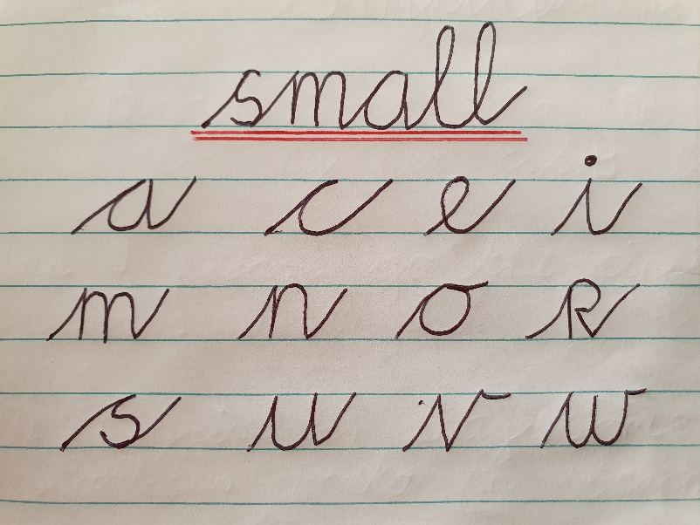

- When children are learning to write in cursive style they should try to get the size, slope and the join correct. They should not lift the pencil.
- All of these small letters start on the line, then each begins with an upstroke and these letters finish with an upward stroke to the top of the next letter. The letters “o, v and w” finish with a curve to the top to the next letter. The join is a shallow horizontal curve. It must be the right length to keep the space between the letters the same.
- When “e” follows a letter which finishes in an up-stroke, the up stroke is continued up and around to form the e.
- When “s” is the last letter of a word, it does not need the upstroke.

- “r” begins like “s” with an upstroke that goes a little bit above the top blue line.
Low letters:
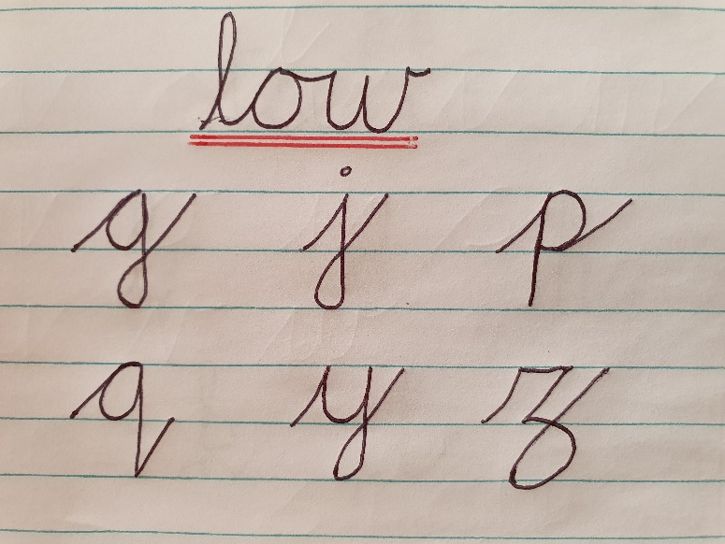

- All of these low letters start on the line, each begins with an upstroke to the top of the letter and then go beneath the line. “p” and “q” are not looped while all the others are looped. The loop crosses on the bottom line and this continues to the finish which is an upward stroke to the top of the next letter.

Tall Letters:
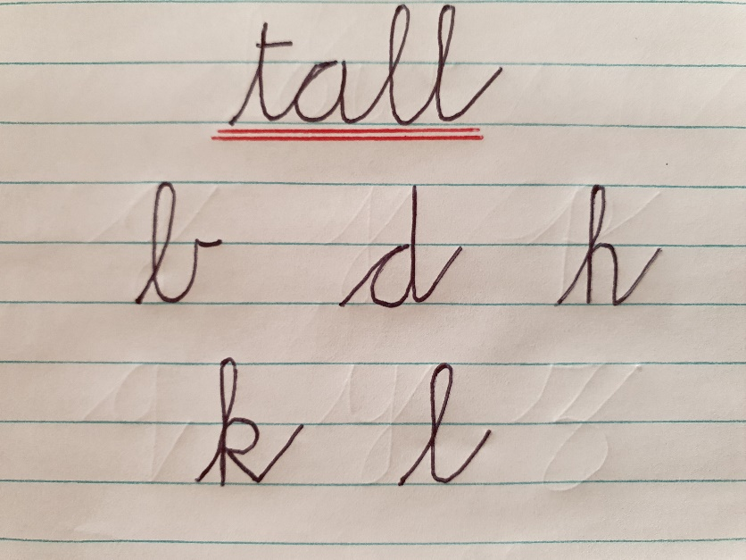

- All of these tall letters start on the line, each begins with an upstroke to the top of the letter.
The loop join comes half way up the length of the letter. Each letter ends with an upward stroke to the top of the next letter.

Different Letters:
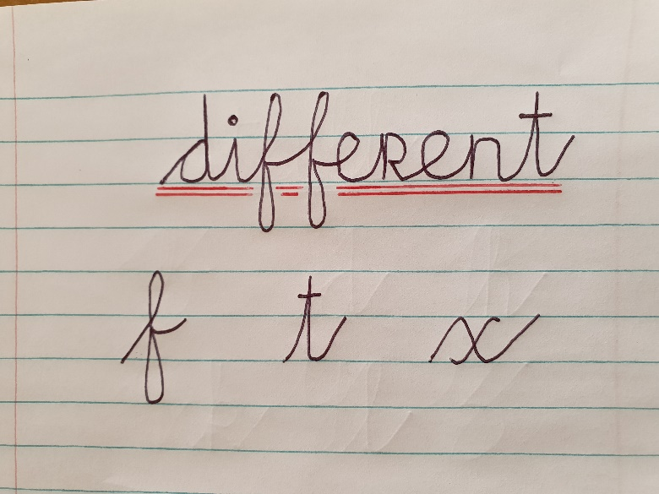

- All of these tall letters start on the on the line, “f and t” begin with an upstroke to the top of the letter – “t” does not go to the top of the line.
- In “f” the loop join comes half way up the length of the letter. The line continues down to half way to the line beneath it. Then the line loops back up to the first loop. The “f” finishes with a curved line to the next letter
- In “t” the letter begins with an upward stroke to the top of the “t” and finishes with an upstroke to the top of the next letter. Remember to cross the “t” when you finish the word.
- The letter “x” begins with an upstroke, then a diagonal stroke down to the baseline, and then another upstroke. To finish the letter, lift your pencil and draw a backward cross through the middle of the diagonal stroke.

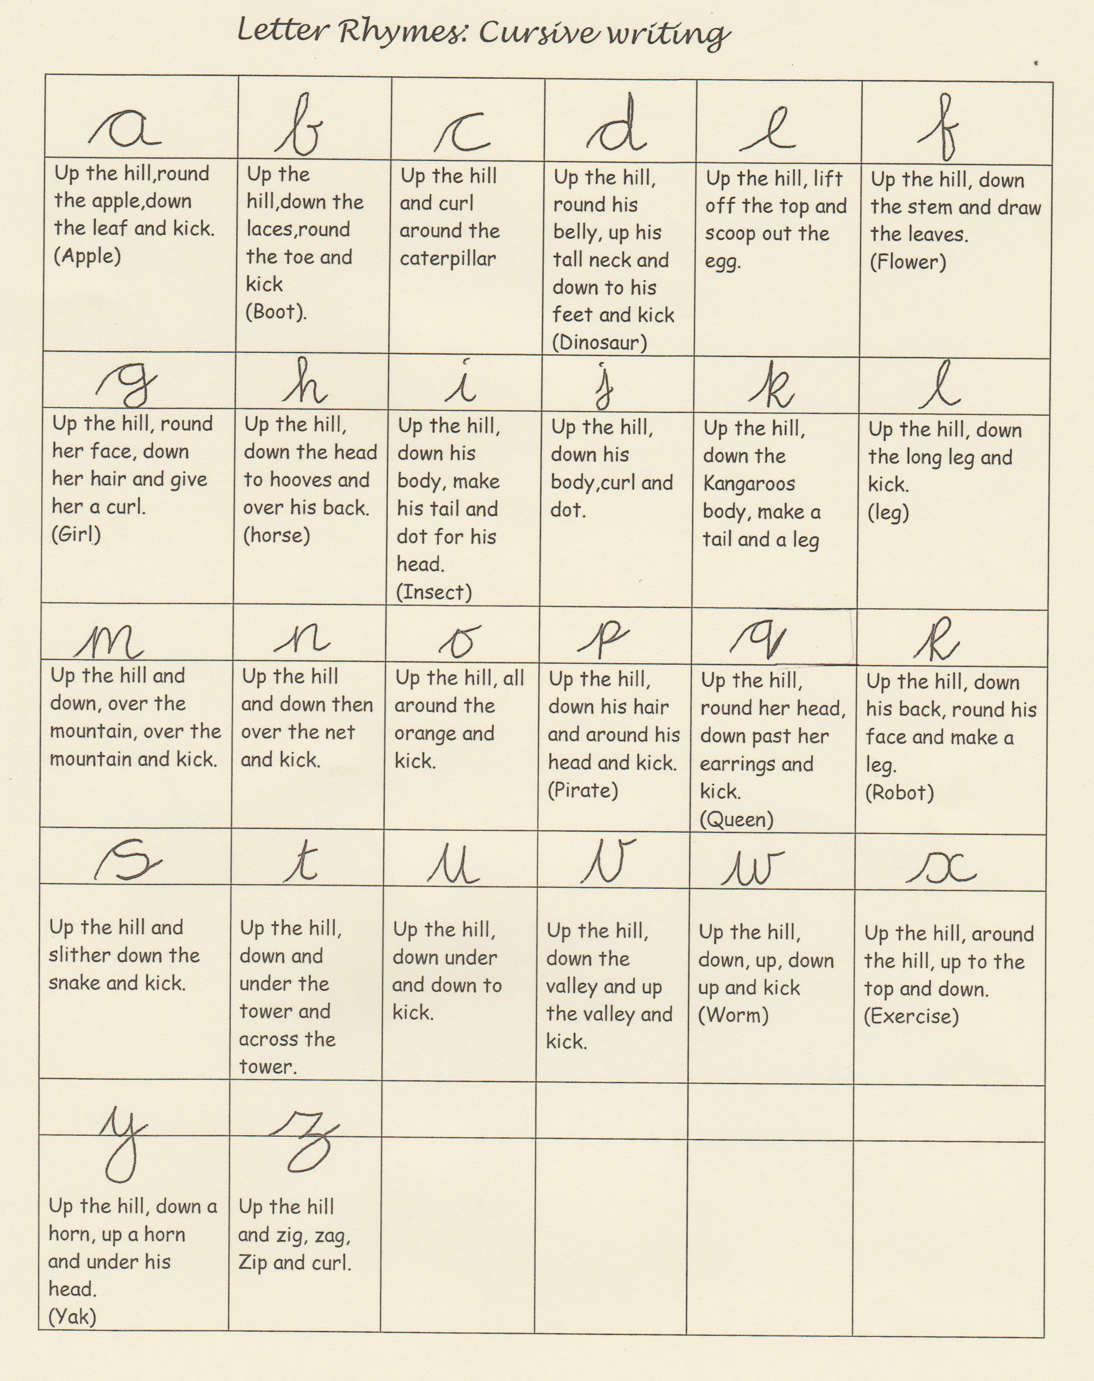

Cursive Script Upper Case Letter Formation Guide

- The capital letters are slightly different. They need plenty of practice.
- Some capital letters have a join loop while others don’t.

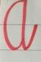 | This letter is formed like the lowercase letter and it finishes with an upstroke.
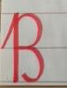 | B is formed differently to the lower case letter. B begins with an upstroke. This letter does not join to other letters.
 | C is like the lowercase letter
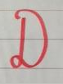 | D is formed differently to the lowercase letters. D does not join with other letters.
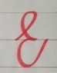 | E is formed differently to the lowercase letter. E begins with an upstroke from the mid line to form a loop and finishes with an upstroke to the top the next letter or mid-way between lines.
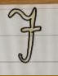 | F is formed differently to the lowercase letter. Lift your pencil to cross the F after you have finished the letter. F does not join with other letters.
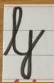 | G is formed differently to the lowercase letter. Capital G begins with an upstroke and finishes with a joining stroke. G forms a loop at the bottom line and finishes with an upstroke at the top line.
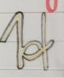 | H is formed differently to the lowercase letter. When writing the H, you will need to lift your pencil
 | I is formed differently to the lowercase letter. The Capital letter I does not join to other letters.
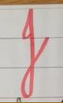 | J is formed differently to the lowercase letter. The Capital letter J joins to other letters.
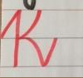 | K is formed differently to the lowercase letter. The Capital K begins with an upstroke and finishes with a joining stroke. You must lift your pencil when forming K.
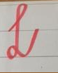 | L is formed differently to the lowercase letter.L begins with an upstroke from the bottom line to form a loop. L forms a small loop at the bottom line and finishes with an upstroke at the top of the next letter.
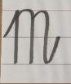 | M is formed like the lowercase letters. It starts with an upstroke. The M begins with an upstroke and finishes with a joining stroke.
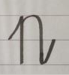 | N is formed like the lowercase letters. It starts with an upstroke. The N begins with an upstroke and finishes with a joining stroke.
O is formed like the lowercase letters.
The Capital letter O does not join to other letters.

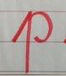 | P is formed differently to the lowercase letter. The Capital P begins with an upstroke and finishes with a joining stroke.
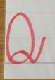 | Q is formed differently to the lowercase letter. Form an O and then at the start point draw a curved line up and around to outside the Q and finish with a kick to the next letter.
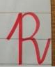 | R is formed differently to the lowercase letter. Start with a stroke up to the top of the letter. Go down and up, go around to halfway and go around and down finishing with a kick to the next letter.
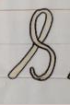 | S does not join to other letters. The S  starts with an upstroke to the top of the S.
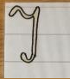 | T is different to the lowercase letter. T does not join to other letters.
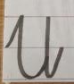 | U is formed like the lowercase letter. Some start with an upstroke and finish with a joining stroke to the next letter.
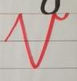 | V is formed like the lowercase letters. V begins with an upstroke and end with a little curve at the top line. V does not form joins to other letters
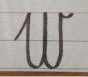 | W begins with an upstroke and ends with a little curve at the top line. It does not join to other letters.
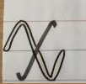 | X is formed like the lowercase letter. Some start with an upstroke. X finishes with a joining stroke. You must lift your pencil when forming X and K.
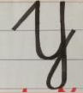 | Y is formed like the lowercase letter. Some start with an upstroke. Y starts with an upstroke and finishes with a joining stroke.
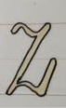 | Z is formed like the lowercase letter and Z ends with an upstroke.

Number Formation Guide

Number | Formation
1 | Start at the top and go straight down
2 | Start at the top, around, down diagonally to a point and straight across.
3 | Start at the top and go around anti- clockwise to half way then go around again to the finish.
4 | Start at the top, go straight down and straight out. Lift your pencil and cross it.
5 | Start at the top, go down and out and around to make a ‘belly’, then lift your pencil to put a hat on it.
6 | Start at the top, go down in a curve and back up and around.
7 | Start at the top, go straight across and then down diagonally.
8 | Start at the top like an “S” and then go back up and around.
q | Start at the top, go out and around, back up and straight down right to the bottom.
o | Start at the top and go around anti- clockwise.

Number Formation Rhymes
The following number formation rhymes are used in Junior and Senior Infants to help teach the children number formation:
1. Number 1 is like a stick, a straight line down, that’s very quick!
2. Number 2 go right around, then make a line across the ground!
3. Number 3 go right around, what will it be? Go round again to make a 3!
4. Down and over and down some more, that’s the way to make a 4!
5. Go down and around and then you stop, finish the 5 with a line on top!
6. Make a curve and then a loop, you’ve made a 6, so join the troop!
7. Across the sky and down from heaven, that’s the way to make a 7!
8. Make an “S” and then don’t wait, climb up again to make an 8!
9. Make a loop and then a line, that’s the way to make a 9!
10. Make a 1 and then an 0, 10 are all your fingers you know!

